Flashlight

Subject: Optics, circuits, electricity, light  Related Subjects:Architecture, Civil Engineering, Physics, Electronics | Grade Level(s):  Length of Lesson: | Type: Inquiry / Design / Project  Keywords:Series circuit, LED, switch, open circuit, closed circuit

Lesson Overview

The first flashlight was invented about 1896. Portable electric lights were called "flash lights" since they would not give a long steady stream of light. The carbon filament bulbs were inefficient and the batteries were weak, allowing the user to flash the light on for only a few seconds.

Lesson Focus
Students will build two series circuits controlled by 2 switches to create a multi-bulb flashlight using LEDs for bulbs.

Lesson Objective(s) | - Students will create two series circuits with a switch.  - Students will create flashlight using mylar, LED and toilet paper roll.

Lesson Timing

5 minutes | Introduce the Lesson
30 minutes | ...

Materials | - – Toilet paper roll  - –LEDs (2 different colors)  - –Toggle Switches  - –Push button switches  - –AA Battery holders  - –Insulated wire  - –Wire cutters  - –AA Batteries  - –Mylar sheet  - –Scissors
Instructor Prep | - Step 1
Related Resources | - List related lessons/ppts etc available from USC or outside, trusted orgs

Lesson Plan

Introduction
A series circuit is formed when an electrical source (battery) is connected to an object (motor, light…), which is connected to a switch, which is connected back to the battery.
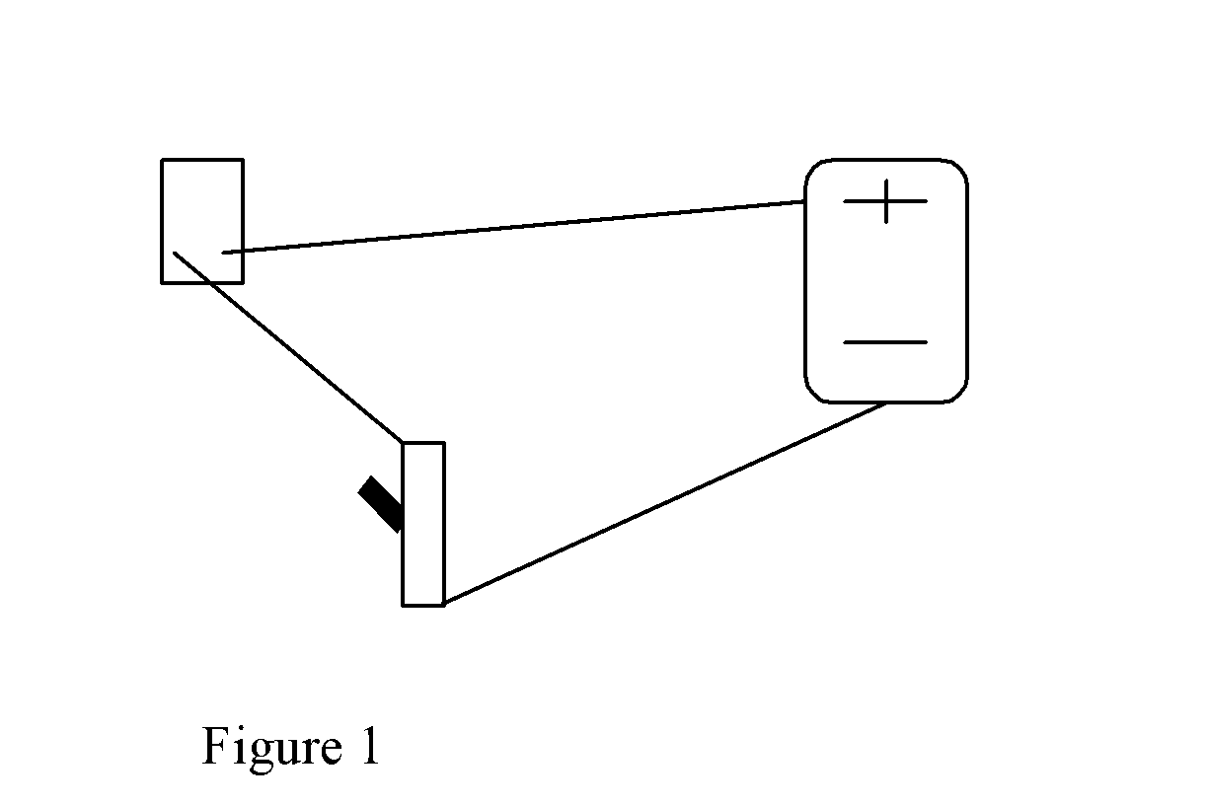

When the switch is off, the circuit is open and electricity can’t flow. When the switch is on, the circuit is closed and electricity can flow.

The switch in this project has 2 positions and three posts (legs). The switch connects the wire attached to the center post to the wire connected to the outside post furthest away from the resting position of the switch. For example, if the switch points left, the middle wire is connected to the wire on the right.

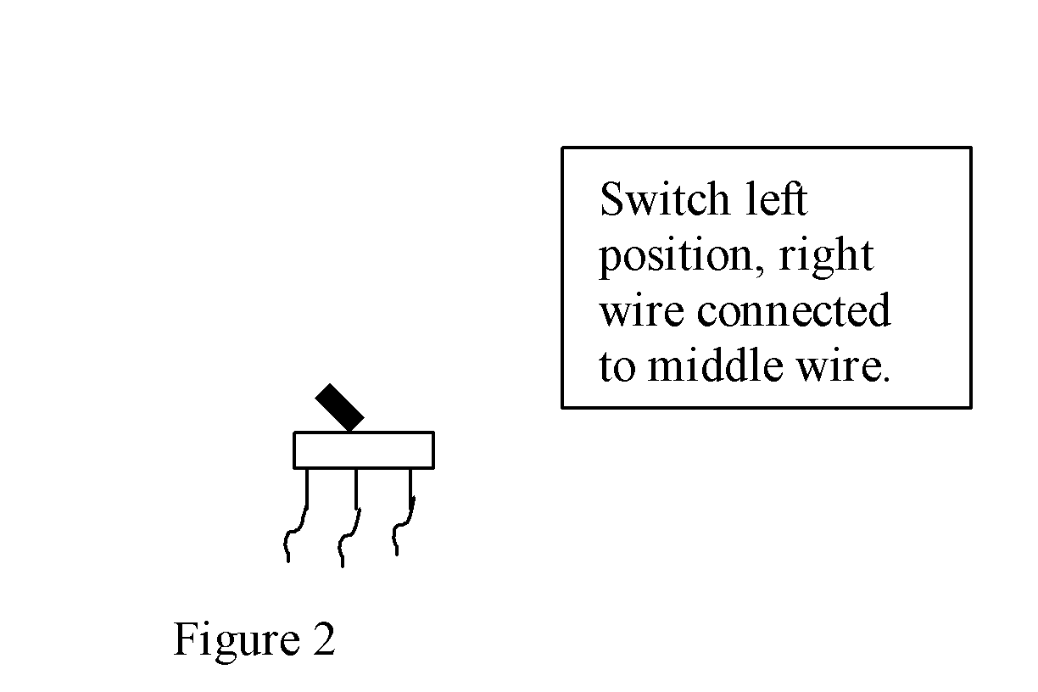

LED's are special diodes that emit light when connected in a circuit. The most important part of a light emitting diode (LED) is the semi-conductor chip located in the center of the bulb. Because they are circuits, LEDs are connected a certain way. The long leg of an LED must be connected to the positive part of the battery. In this project, the LED needs at least 2-AA batteries to turn on.

To maximize the projection of light, a flashlight must have a reflective surface around the light. Students will create a reflective cone out of Mylar for the inside of the toilet paper roll.

Most flashlights won’t work on the first attempt. There are two primary reasons (assuming all connections are correct):
- Open circuit – two wires that should be connected are not in contact with each other
- Short circuit – two wires that aren’t supposed to be connected are touching (on the metal part)

Both of these can cause a circuit not to function. Students must troubleshoot for both, pull wires apart, reconnect and re-tape if necessary.

Procedure

Safety Procedures
- Caution must be exercised with wire strippers and scissors
- Caution must be exercised with hot glue gun

Instructions

– Cut and strip both ends of 3 – 5” wires. (Strip about 1 ½ inches from each end).
–Twist one wire around long leg of 1st LED and tape
–Twist 1st LED wire to one of the outer post of switch.
–Twist 2nd wire around long leg of 2nd -LED and tape
–Twist 2nd LED wire to other outer post of switch.
–Strip both wires from battery holder
–Twist red wire from battery holder to center post of switch and tape
–Twist free wire to short legs of both LEDs.
–Twist short leg LED wire to either post of push button switch.
–Twist black wire from battery holder to other post from push button switch and tape.
–Insert batteries into battery holder.
–Test circuits by pushing push button, changing position of switch and pushing button again. One light will come on in one switch position, the other will come on in the other.
–Make necessary adjustments until both lights work
–Remove batteries from battery holder.
–Cut 5” x 3” Mylar sheet.
–Form cone with sheet leaving small opening at bottom.
–Insert cone inside toilet paper roll, tape to end and trim.
–Feed LEDs through cone from bottom of roll.
–Poke a hole 2” from bottom and 1” from bottom of roll.
–Remove nut from push button and switch.
–Push switches through holes and reconnect nut for each.

–Glue battery holder to bottom of roll.

–Switch has 2 positions, LED 1 and LED
–Switch to either LED and press button to activate.
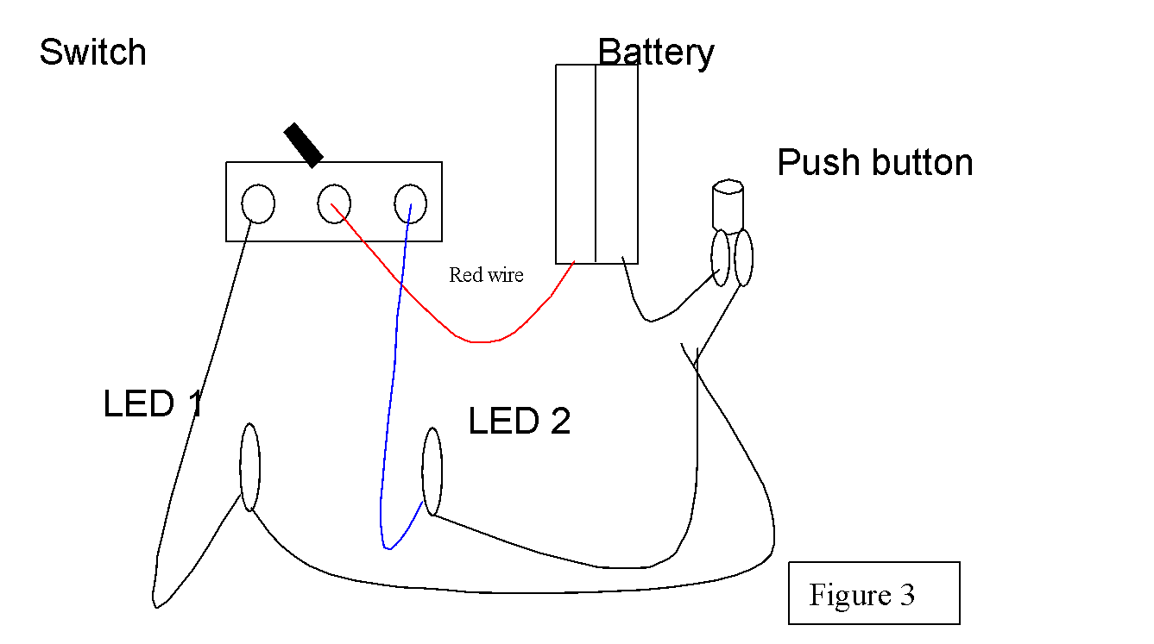

Wrap-up
- Students will develop ways to make toilet paper roll more sturdy.

Lesson Background for Teachers

Suggested Real-World STEM Connections
- List possible related Role Models in STEM (with details and links to more reading). Give suggestions for examples of scientists/engineers who are from underrepresented groups in STEM in related careers.
- List related real-world engineering problems and examples

Lesson Variations and Options
Include descriptions of alternative methods or ways to present things.

Explanation
Describe the background concepts and explanations behind the lesson. This can be more in depth than a teacher/instructor would actually share with students.

Key Concepts and Vocabulary
- Word 1: Grade Appropriate Definition
- Word 2: Grade Appropriate Definition

Safety Notes
- Safety instruction

